The JMeter is being run on a Window 11 PC and JAVA version 8.   
For Mac, it may have a bit of a difference.  
Please download JAVA before doing the following

1. Please check whether Java is being installed in the PC, if not, please download Java via the official site <https://www.java.com/download/ie_manual.jsp>
2. After the Java installation has been completed or it has been installed before, please follow the steps below
3. Access the official download site of JMeter (<https://jmeter.apache.org/download_jmeter.cgi>)  
   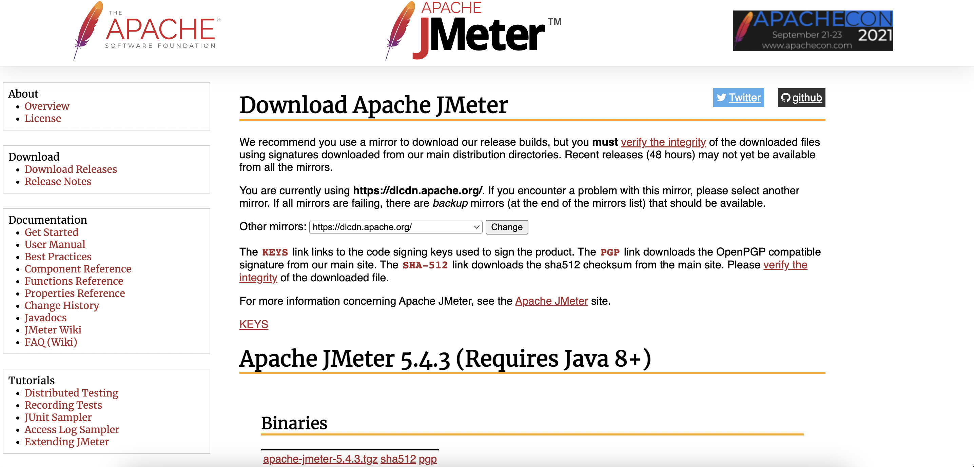
4. Download the Apache JMeter 5.4.3 (Requires Java 8+)  
   apache-jmeter-5.4.3.zip  
   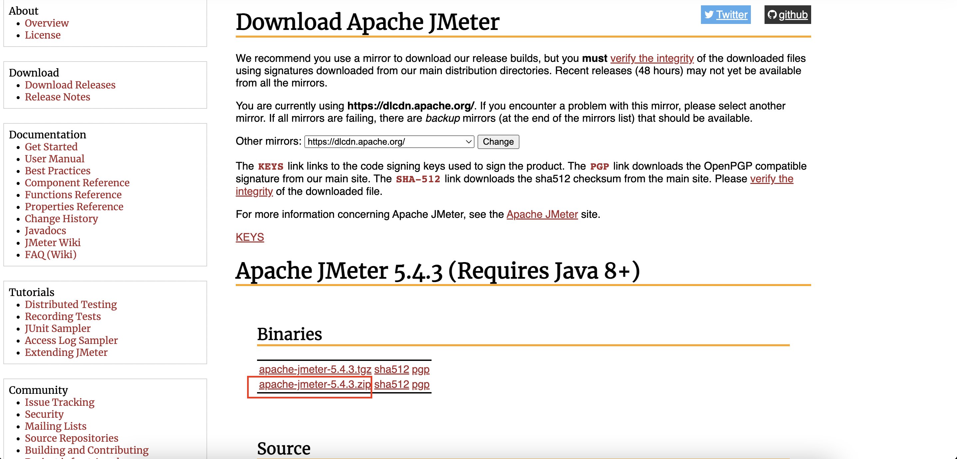
5. Unzip the “apache-jmeter-5.4.3.zip”  
   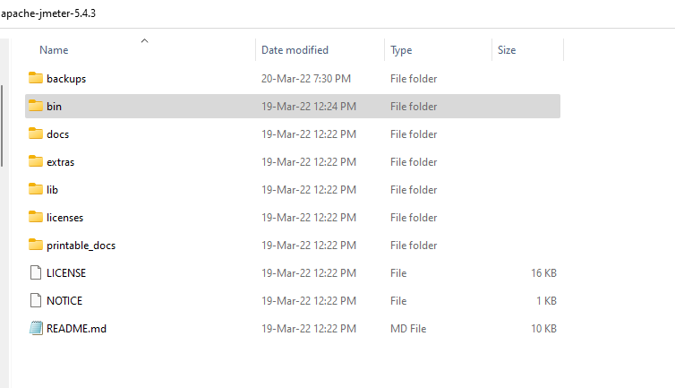
6. To start the JMeter application , double click the “jmeter.bat” in the “apache-jmeter-5.4.3/bin”  
   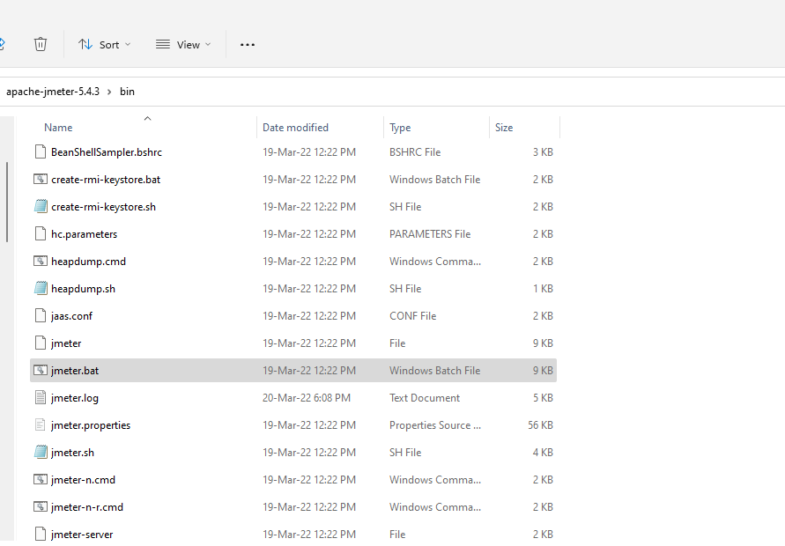  
     
   The cmd and GUI of JMeter should be loaded as below  
   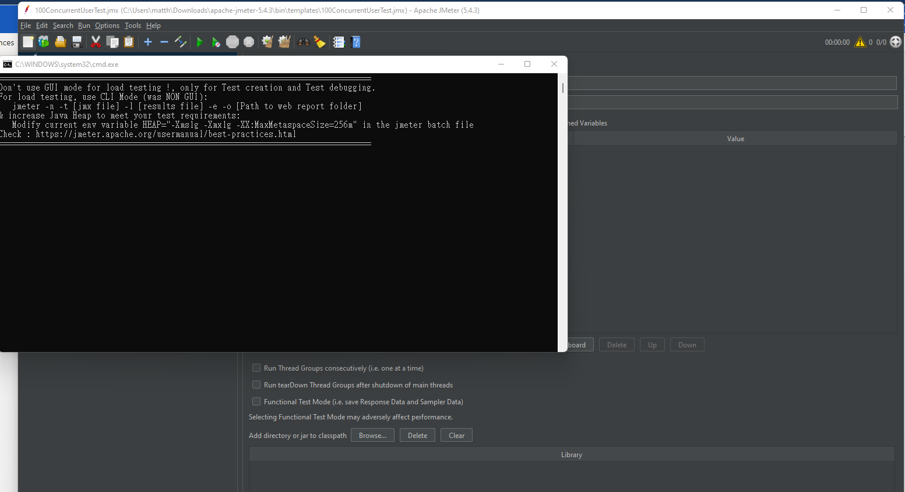
7. Create a new Test plan by clicking the top left blank paper icon   
   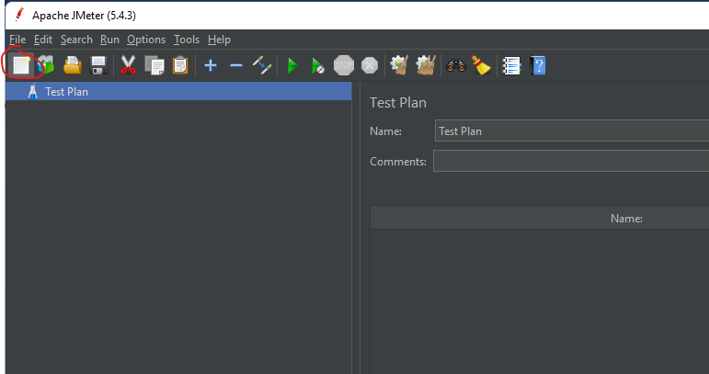
8. Add a Thread Group by right clicking the “Test plan” created in previous step, hover on “Add” and then select “Thread Group”  
   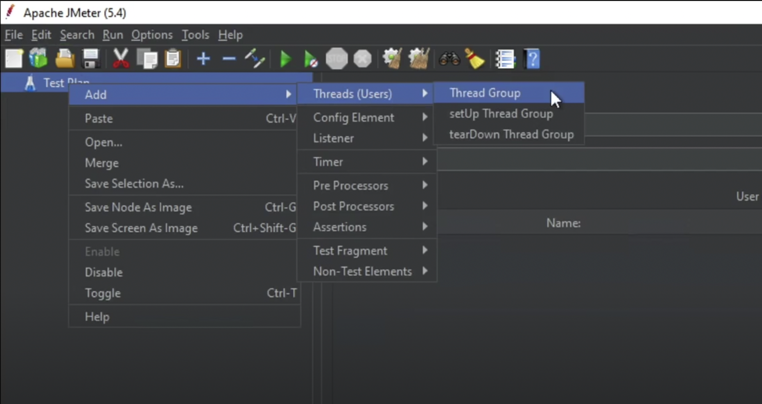
9. In the thread group settings, we will have the following settings:
   1. Name: “50 concurrent user”
   2. Action to be taken after a sample error
   3. Thread properties
      1. Number of threads
         1. 50
      2. Ramp up period
         1. 5
      3. Loop count
         1. 1
   4. Same user on each iteration
      1. Untick
   5. Delay thread creation until needed
      1. Untick
   6. Specify Thread lifetime
      1. Untick

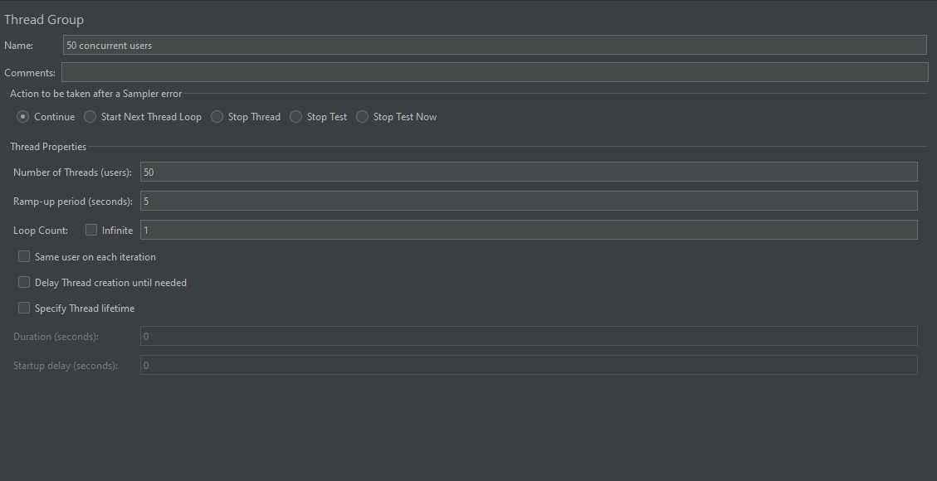

1. Add a new HTTP request by right clicking the “50 concurrent user” thread group, hover on “Add”, then hover on “Sampler”, lastly select “HTTP Request”  
   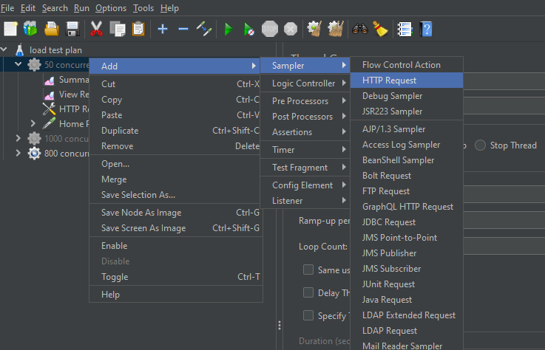
2. In the “HTTP Request”, we will have the following settings:
   1. Name: “3 MB page”
   2. Basic
      1. Web server
         1. Protocol (http):
         2. Server Name or IP
            1. (Please insert the public IP address of one of the EC2 servers)
         3. HTTP request
            1. GET
         4. Path
            1. /index.html
         5. Parameter (all blanks)

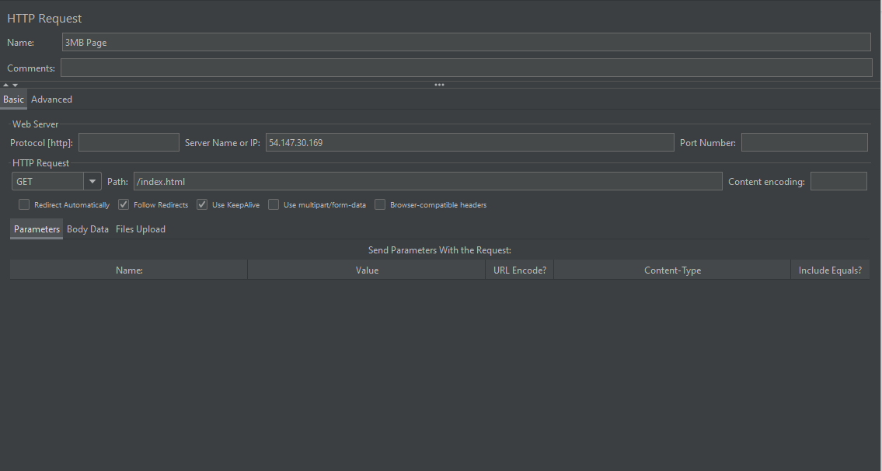

1. Add a new HTTP request by right clicking the “50 concurrent user” thread group, hover on “Add”, then hover on “Listener”, lastly select “Summary Report”  
   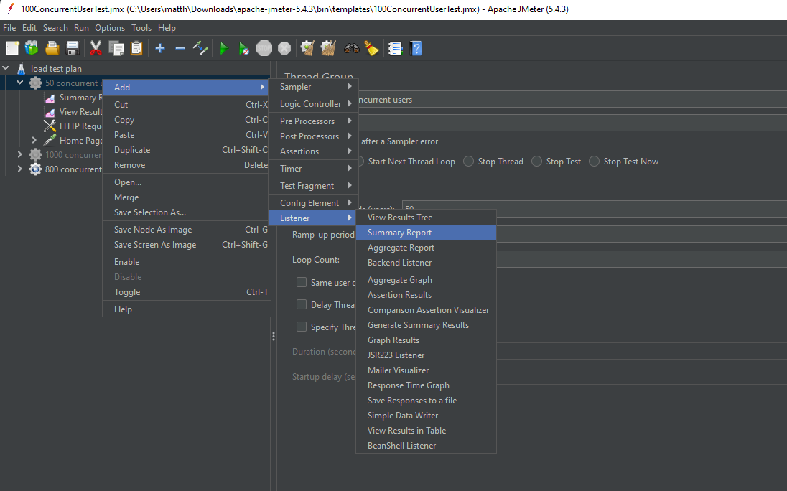
2. The result of the test can be found in the “Summary Report”  
   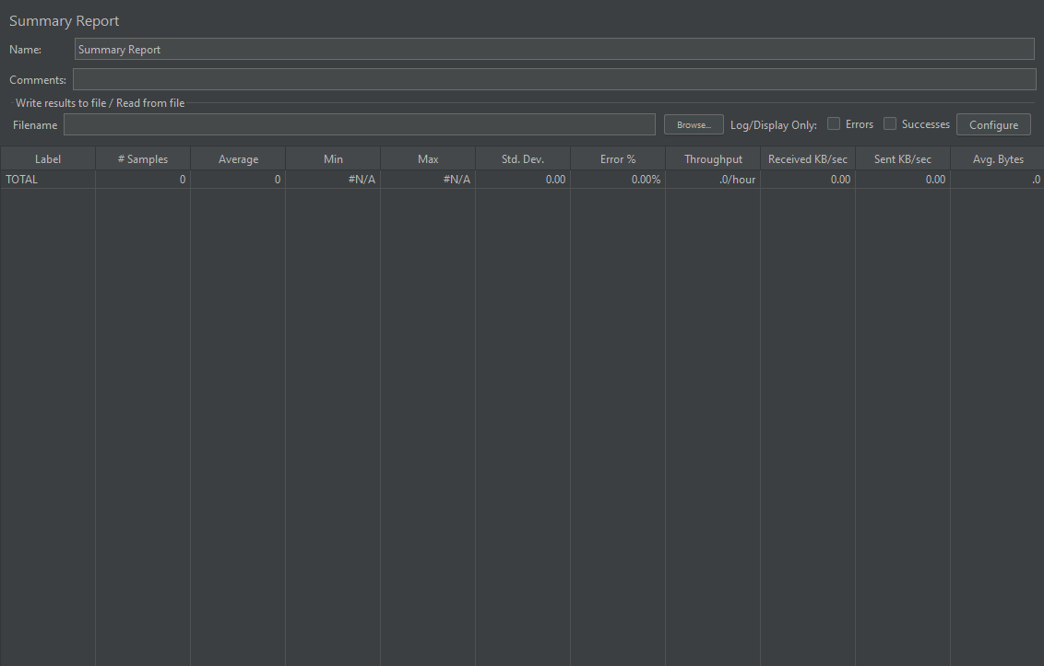
3. For establishing the test on 200 concurrent users, repeat step 8 – 13, but with different settings in the thread group settings, we will have the following settings:
   1. Name: “200 concurrent user”
   2. Action to be taken after a sample error
   3. Thread properties
      1. Number of threads
         1. 200
      2. Ramp up period
         1. 20
      3. Loop count
         1. 1
   4. Same user on each iteration
      1. Untick
   5. Delay thread creation until needed
      1. Untick
   6. Specify Thread lifetime
      1. Untick

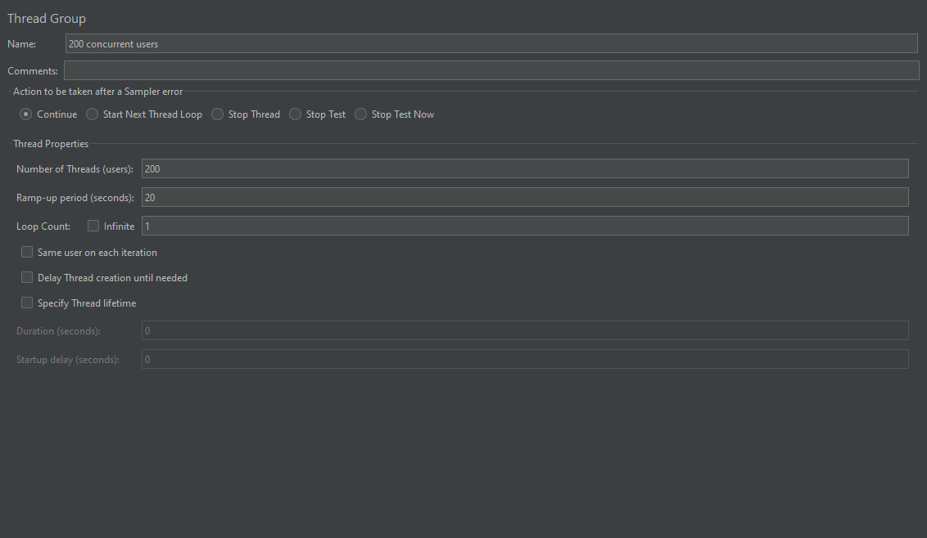

1. For establishing the test on 800 concurrent users, repeat step 8 – 13, but with different settings in the thread group settings, we will have the following settings:
   1. Name: “800 concurrent user”
   2. Action to be taken after a sample error
   3. Thread properties
      1. Number of threads
         1. 800
      2. Ramp up period
         1. 80
      3. Loop count
         1. 1
   4. Same user on each iteration
      1. Untick
   5. Delay thread creation until needed
      1. Untick
   6. Specify Thread lifetime
      1. Untick

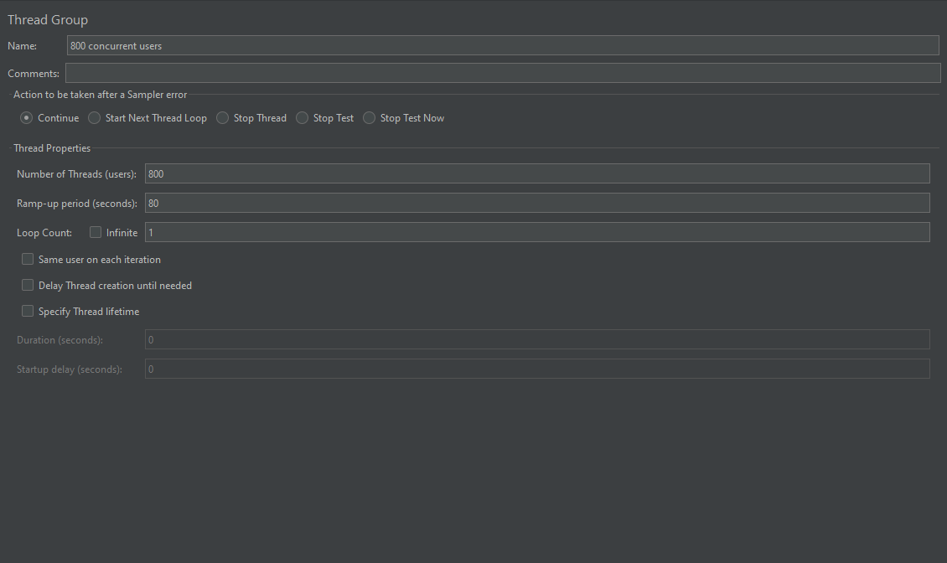

1. For testing 5MB response size, change the settings in the “HTTP Request”, we will have the following settings:
   1. Name: “5MB page”
   2. Basic
      1. Web server
         1. Protocol (http):
         2. Server Name or IP
            1. (Please insert the public IP address of one of the EC2 servers)
         3. HTTP request
            1. GET
         4. Path
            1. /index.html
         5. Parameter (all blanks)
2. For testing 1MB response size, change the settings in the “HTTP Request”, we will have the following settings:
   1. Name: “1MB page”
   2. Basic
      1. Web server
         1. Protocol (http):
         2. Server Name or IP
            1. (Please insert the public IP address of one of the EC2 servers)
         3. HTTP request
            1. GET
         4. Path
            1. /index.html
         5. Parameter (all blanks)